Tutorial – Workplace Health and Safety

In this tutorial we are going to identify the hazards in your workplace, assess their level of risk, and list some control methods that can be implemented to reduce the level of risk associated with a hazard.

This exercise should be done either as a class (focusing on in-class discussion). For those studying online, complete the exercises individually (by analysing your individual working environment) and discuss your results with your class

If you are studying on-campus, you should identify and assess the hazards in your classroom. If you are an online student you will identify and assess the hazards in your home office or study space.

You will be assessed on your in-class participation for this exercise. Failing to participate in the discussion will result in additional follow up assessment items for you to complete/participate in.

1. Identify Hazards:

Identify hazards in your workspace. List each hazard in the table below.

Use the Risk Matrix on page 2 to measure the risk level of each hazard.

Discuss each hazard with your class or in groups. Do you all agree on the risk level?

|  |  |  |  |
| --- | --- | --- | --- |
| Hazard | Consequence | Likelihood | Risk Level |
|  |  |  |  |
|  |  |  |  |
|  |  |  |  |
|  |  |  |  |
|  |  |  |  |
|  |  |  |  |
|  |  |  |  |
|  |  |  |  |
|  |  |  |  |
|  |  |  |  |
|  |  |  |  |
|  |  |  |  |
|  |  |  |  |

|  |  |  |  |  |  |
| --- | --- | --- | --- | --- | --- |
| IMPACT | LIKELIHOOD | | | | |
| Rare (1) | Unlikely (2) | Possible (3) | Likely (4) | Almost Certain (5) |
| Catastrophic (A) | M | M | H | C | C |
| Major (B) | L | M | M | H | C |
| Moderate (C) | L | M | M | M | H |
| Minor (D) | L | L | M | M | M |
| Insignificant (E) | VL | VL | L | L | M |

|  |  |
| --- | --- |
| Risk level | Required action |
| Critical | Act immediately:  The proposed task or process activity must not proceed. Steps must be taken to lower the risk level to as low as reasonably practicable using the hierarchy of risk controls. |
| High | Act today:  The proposed activity can only proceed, provided that:  (i) the risk level has been reduced to as low as reasonably practicable using the hierarchy of risk controls;  (ii) the risk controls must include those identified in legislation, Standards, Codes of Practice etc.  (iii) the risk assessment has been reviewed and approved by the Supervisor and  (iv) The supervisor must review and document the effectiveness of the implemented risk controls. |
| Medium | Act this week:  The proposed task or process can proceed, provided that:  (i) the risk level has been reduced to as low as reasonably practicable using the hierarchy of risk controls;  (ii) the risk assessment has been reviewed and approved by the Supervisor. |
| Low | Act this month:  Managed by local documented routine procedures which must include application of the hierarchy of controls. |
| Very Low | Keep a watching brief:  Although the risk level is low the situation should be monitored periodically to determine if the situation changes. |

2. Recommend Control Mechanisms:

Now that you have identified the hazards in your work environment and allocated a level or risk to each hazard, propose solutions to minimize the risk of each hazard.

Discuss each hazard in your class or in groups and collectively decide on the best control method. Is there more than one control method you could use for each hazard? Which methods would be the most effective at reducing risk? What training would be required to make sure employees understood or could use the new controls?

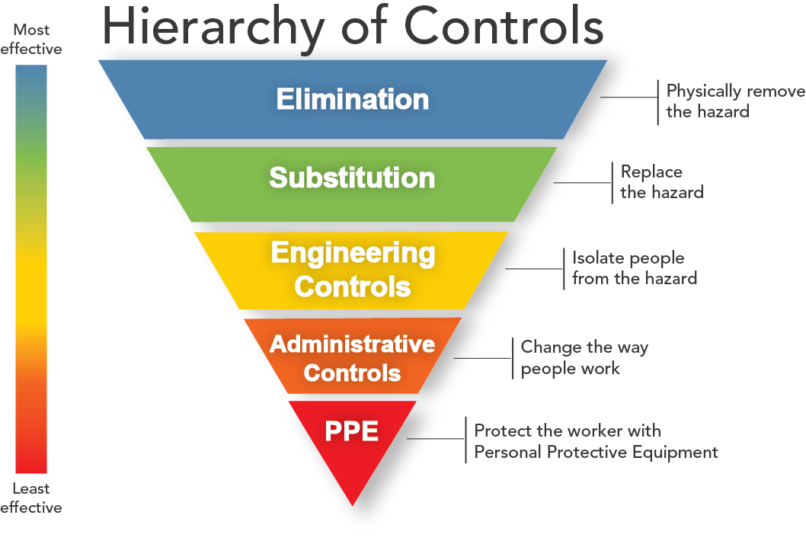

For each hazard try to use one of the more effective methods of control first. If that is not possible, a less effective method will suffice.

Complete the table below, listing one or more control methods for each hazard you identified above.

|  |  |
| --- | --- |
| Hazard | Control Method |
|  |  |
|  |  |
|  |  |
|  |  |
|  |  |
|  |  |
|  |  |
|  |  |
|  |  |
|  |  |
|  |  |
|  |  |
|  |  |

Once you have filled in both tables, submit this worksheet to your teacher for assessment.